A PROJECT TITLED

FAROSHGAH

By

KALEEM ULLAH 3329-FBAS/BSSE/F16 USMAN SERVER 3342-FBAS/BSSE/F16

IN PARTIAL FULLFILLMENT OF

**BS IN SOFTWARE ENGINEERING**

DEPARTMENT OF COMPUTER SCIENCE AND SOFTWARE ENGINEERING

FACULTY OF BASIC AND APPLIED SCIENCES

**INTERNATIONAL ISLAMIC UNIVERSITY ISLAMABAD (2021)**

## FINAL APPROVAL

**Dated:** It is certified that we have read the project report titled “Faroshgah” submitted by **Mr. Kaleem Ullah (**3329-FBAS/BSSE/F16**)** and **Mr. Usman Sarwar (**3329- FBAS/BSSE/F16**)**. It is our judgment that this project is of sufficient standard to warrant its acceptance by the International Islamic University, Islamabad for Bachelor’s Degree in Computer Science.

### COMMITTEE

**External Examiner:** Mr. Muhammad Nadeem Assistant Professor

Department of Computer Sciences & Software Engineering International Islamic University, Islamabad

##### Internal Examiner:

Mr. Iftekhar Ali Khan Lecturer

Department of Computer Sciences & Software Engineering International Islamic University, Islamabad

##### Supervisor:

Mr. Muhammad Nadeem Assistant Professor

Department of Computer Sciences & Software Engineering International Islamic University, Islamabad



"In the Name of ALLAH, the Most Beneficent, the Most Merciful"

## Dissertation

A dissertation submitted to

Department of Computer Science & Software Engineering, International Islamic University, Islamabad

As partial fulfillment of the requirements for award of the degree of

BS in Software Engineering

*Dissertation*

## DECLARATION

We hereby declare that we developed this software and this report entirely on the basis of our personal efforts made under the sincere guidance of our project supervisor Mr.

Muhammad Nadeem. No portion of this work presented in this report has been submitted in support of our applications from any other degree or qualification of this or any other University or institute of learning. We further declare that this software and all associated documents, reports are submitted as partial requirements for the degree of BS in Software Engineering.

##### Kaleem Ullah

3329-FBAS/BSSE/F16

##### Usman Sarwar

3342-FBAS/BSSE/F16

## ACKNOWLEDGEMENT

We might want to express gratitude toward Almighty Allah who blessed us the fortitude and ability to finish this undertaking. Allah made us ready to use every one of our aptitudes, endeavors and information to make this venture. Without His assistance, we would not have done this venture totally. During all the periods of this venture His approval made our ways simple and we achieve this undertaking Alhamdulillah.

We would like to express special thanks of gratitude to our respected supervisor **Mr. Muhammad Nadeem** who gave us the guidance and support in completing this wonderful project Faroshgah, which also helped us in doing a lot of Research and we came to know about so many new things. We are really thankful to them.

Secondly we would also like to thank our parents and friends who helped me a lot in finalizing this project within the limited time frame.

|  |  |
| --- | --- |
|  | **BROJECT IN BRIEF** |
| Project Title | Faroshgah |
| Version | 1.0 |
| Development Team | Kaleem Ullah  Usman Server |
| Supervised by | Mr. Muhammad Nadeem |
| Date Started | Aug 2020 |
| Date Completed | June 2021 |
| Programming Languages | Java, JavaScript, HTML, CSS |
| Technologies | Express, NodeJS, React Native, MongoDB, Git |
| Tools | Android Studio, VS Code, Postman, Robo 3T, MongoDB Atlas, GitHub |
| Deployment Servers | 1. Heroku, 2. MongoDB Atlas Database- Cloud DBaaS for MongoDB |
| System Used | Core-i7, RAM-6GB, Microsoft Windows 10 |

## ABSTRACT

Faroshgah is Mobile Application used to facilitate the students, jobholders, and individuals to interact with Hostels, shopkeepers and job providers via internet.

This app that is being developed as final year project can be helpful in facilitating students to get a job online, in booking hostel online, search hostels by location, book hostel, and third important thing is that this mobile app provides a platform to buy things from shopping stores online.

This project developed using fifth generation languages and technologies. We used languages JavaScript, NodeJS and technologies like React Native.

By using these technologies we were able to develop hybrid mobile app that can run on both Android and Mac execution environments.

This software is fully secured, scalable, robust and flexible. It provides fully encrypted environment for sensitive data of user like passwords, we were able to develop such secured system by using JSON Web Token.

The aim of this project is to develop software for students who come here in large cities to get higher education but they feel it difficult to find good hostels online. This application aims to help students in finding hostels, getting jobs and shopping via internet using mobile application. This reflects the forecast availability of hostels via internet for students and also provides opportunity to get jobs online.

*Table of Contents*

Table of Contents

FINAL APPROVAL 1

COMMITTEE 1

Dissertation 3

DECLARATION 3

ACKNOWLEDGEMENT 4

ABSTRACT 6

CHAPTER 1 INTRODUCTION 8

1. INTRODUCTION 9

PURPOSE 9

SCOPE 9

OVERVIEW 10

POSITIONING 10

PRODUCT FEATURES 12

ADVANTAGES 12

CONSTRAINTS 12

CH#2 SYSTEM ANALYSIS 14

2. SYSTEM ANALYSIS 14

Use Case Diagram 15

Table 2.10 Use Case Delete Jobs by Provider 33

CHAPTER 3 SYSTEM DESIGN 34

System Sequence Diagram 34

CLASS DIAGRAM 40

3.4 Deployment Diagram 42

CHAPTER 4 IMPLEMENTATION 44

Functional Features of the Model: 44

TOOLS AND TECHNIQUES 44

CHAPTER 5 65

5. System Testing 65

Black Box Testing 65

White Box Testing 65

Test Cases 65

CHAPTER 6 CONCLUSION 74

5. CONCLUSION 74

FUTURE EXTENSION 75

REFERENCES 75

# CHAPTER 01

# INTRODUCTION

## 

## INTRODUCTION

With the advancement of technology, application areas of computer are rising day by day. Every sector desires its procurement for fast accurate and automated operations. Therefore different programs are being developed to provide facility using digital technologies.

This project entitled “Faroshgah” a project made by considering the necessities of the modern world. This system aims to provide online facilities using internet. It is mobile app software which is helpful in the areas of Hostels, shops and jobs. This system provides facility of booking hostel online, shopping online and even someone can apply for job by using this mobile app. This project aims to connect students with hostels via internet, buying things online, and provides facility to get job online.

In terms of security this software is totally secure as it doesn't give access to unauthorized user as the sensitive data like passwords are fully encrypted.

### PURPOSE

The main objective behind preparing this project is that to make it possible to book hostel online, get job online, and shop online:

1) To find the Hostel online with ease.  
2) To save time.  
3) To increase efficiency of students.  
4) For fast access of hostels, jobs and shops.  
5) For secure and smooth running of the program.  
6) For error free, effective and easy for database related works.  
7) indicate the hostel availability and the location of the hostels;

### SCOPE

Enabling students/jobholders to connect with the digital world. Providing the facility of using the internet in a useful manner from finding hostels online to book hostel online and from finding shops online to buying things from the shops via internet. The job module facilitates the students and individuals to get a job online.

Finding good hostels full of facilitation, finding hostels of your demand on one click easily, in a new city. For finding hostels of your requirements will be easy and booking of rooms in the hostel.

### OVERVIEW

Faroshgah had been development using emerging languages and technologies like NodeJS and React Native, JWT. The main purpose of this program is to enable people to use internet of their ease and facility instead of just entertainment. Due to the fact that NodeJS, React Native are open source programs but also have a very large community.

That’s why development of Faroshgah was not too difficult and we enjoyed it and learned lot of new technologies covered in developing this project.

### POSITIONING

#### **Business Opportunity**

##### This application will be more like a Platform for those who want to promote their Hostel business online, for shopkeepers who want to sell online and for job providers who want to get employees online instead of boring advertisement which seeks both money and time. Users can find best and cheap Hostels without spending any money on searching by visiting manually and it reduces time. It also provides an opportunity to get a job online.

#### **Problem Statement**

|  |  |
| --- | --- |
| **The problem of** | Difficult to find good hostels for new visitors in a city. Difficult to find jobs and shops within specified area and exact requirements. It is difficult and time taking to go to Streets and cities to look for desired shops, hostels and jobs there are many problems for searching things and there is no platform to upload and manage businesses like this.  By making this online we want to make strong or trustful interaction between user and Providers.  It is difficult for shopkeepers to attract customers while being in a low running area.  It is difficult for students and needy people to look for hostels for living and manage hostels manually. |

|  |  |
| --- | --- |
| **Affects** | For Hostel owners, it is difficult, time consuming and costly to advertise their business manually.  For students and job holders outside the country it is Difficult to find best hotels, for job seekers there is great opportunity we provide that they can find jobs easily by location. It is very important that you can find shops listing items and go directly to that shop of your interest by location. |
| **the impact of which is** | Hostel owners will enjoy this great opportunity of posting their hostel online and hostel seekers can find online and can book hostel seat online. Hostel seekers can find hostel by location.  Someone can find jobs of specific location and by items he/she want to get or buy from shop. Also job seekers can find jobs and can apply for job in desired city. |
| **Successful solution would be** | Easy access to hostels with best prices and location. Reduce finding time and booking time. Get your desired job and shop and get it. |

#### **Product Position Statement**

|  |  |
| --- | --- |
| For | Owners & Customers |
| Who | Wants to present and acquire accommodation services |
| That | By using this software hostel owners don’t need to advertise their service in a manual way and students, job holders can get hostel by their choice using online  System instead of visiting each hostel’s door. |
|  |  |
|  | . |

### PRODUCT FEATURES

##### Add up accommodation service

Owner can add the service to other users like students and job holders. Service can be like Hotel searching, reserving seats and providing jobs and shops online.

##### Acquire accommodation service

On the Client side, the user can acquire searching, reserving seat and finding jobs and shops.

##### Search for the Service

The user can search for the services by specifying the location and can give review about the service.

##### Online Payment

User can also pay online. Through Online payment feature the user can pay online to the specified account of the owner or can par directly to the owner.

### ADVANTAGES

* + - Users will easily add and register their accommodation service to App, regarding the user can find it useful after registering.
    - Users will get the required service through the App easily and can book it online, regarding the category of requirement like hostel, seats and can book a seat for them.
    - Users will be able to search and check nearby Hotels, Homes/flats, Marriage halls, hostels, compare them, and choose the appropriate one for self.
    - User doesn’t need to spend money on advertisements and client doesn’t need to spend money to find accommodation service.

### CONSTRAINTS

Users both owner and client, should sign up before registering or acquiring any service. It is role based application. There are three types of roles, admin, publisher and user. Users with role publisher and admin can create hostel, shop or post a job. Users having role user can book room, apply for job, searching, purchase product and can give a review. Admin have fully fledged authority to do anything.

# CHAPTER 02

# SYSTEM ANALYSIS

*System Analysis*

## SYSTEM ANALYSIS

System analysis is the way towards concentrate a methodology or business so as to distinguish its objectives and purposes and make frameworks and strategies that will accomplish them in a productive way. Analyze the problem Understand the problem and its context. One is studying the

existing system and other is to understand the requirements and domain of the new system. Subsequent to investigating the prerequisites of the undertaking to be played out, the following stage is to examine the issue and comprehend its unique circumstance. The main movement in the

stage is examining the current framework. What's more, other is to comprehend the necessities and

space of the new framework. Similarly imperative, yet the main movement fills in as a principle of giving the useful particulars and afterward effective structure of the proposed framework.

Understanding the properties and necessities of another framework is increasingly troublesome and requires innovative reasoning and comprehension of existing running framework is likewise troublesome, ill-advised comprehension of present framework can lead redirection from arrangement.

The model that is fundamentally being pursued is the Water fall Model, which expresses

that the stages are sorted out in a straight request. As a matter of first importance the attainability consider is finished. Analysis model includes:-

. Use case diagram

1. Use case diagram with description
2. System sequence diagram

*Feroshgah*

*17*

## FLOW DIAGRAM

### LOGIN AND REGISTER

### login flow.png

Figure - Login And Registration Flow Diagram

### CREATE HOSTEL

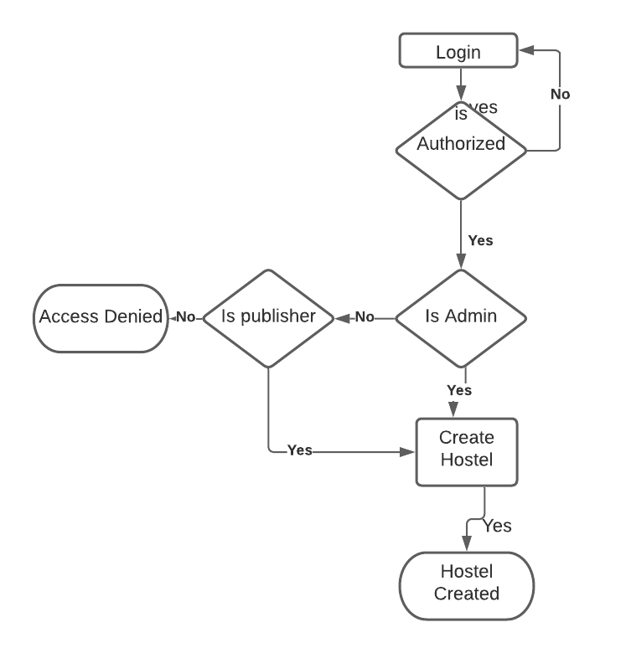

Figure - Create Hostel Flow Diagram

### BOOK SEAT

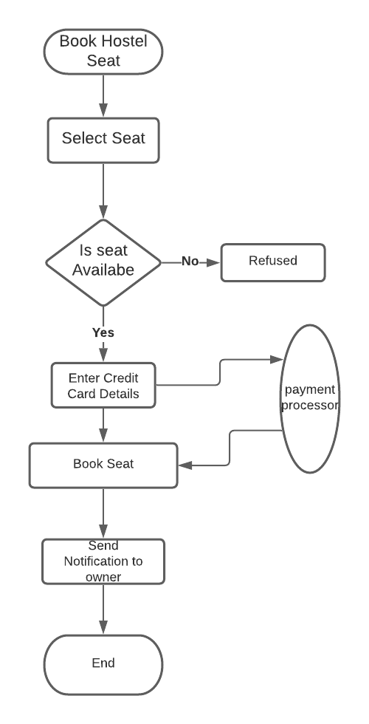

Figure - Book Seat Flow Diagram

### Use Case Diagram

A use case diagram is used to represent the set of actions (use cases) that system can perform with in collaboration with external users of the system (actors). Figure 2.1 shows the relationship between the user and different use cases in which the user is involved.

Figure 2. 1 Use Case Diagram

##### Hostel Use Case Diagram

14

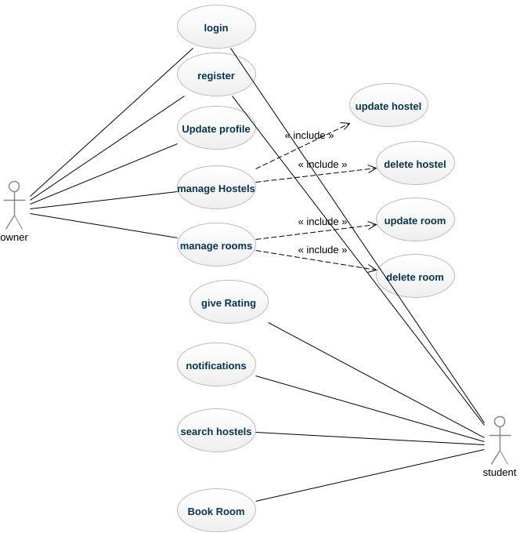

Shops Use Case Diagram

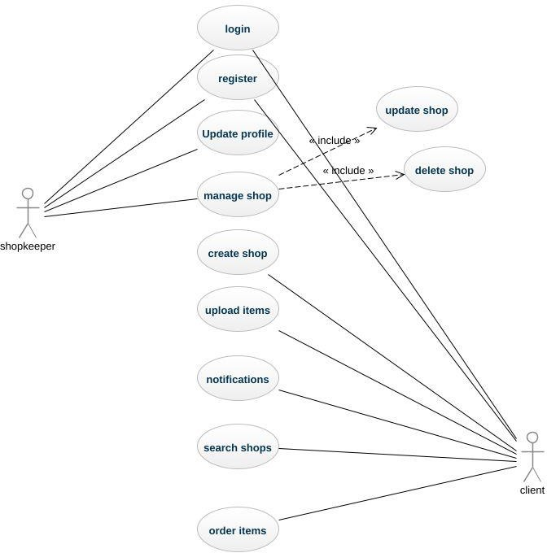

**Jobs Use case diagram**

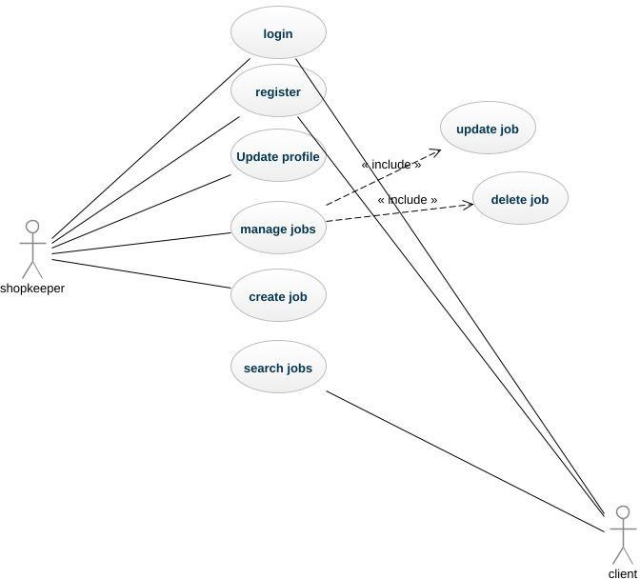

* 1. Use Case Description in Detail Expended Format:

1. In software and systems engineering, a use case is a list of actions or event steps typically defining the interactions between a role and a system to achieve a goal. The actor can be a human or other external system.

##### 2.2.1 Use Case Registration

Details of use case registration which tells how user can register to the application

|  |  |
| --- | --- |
| **Use Case ID no.** | **UC-01** |
| **Scopes** | Meet-up Platform for hostel owner and Client/student |
| **Name** | Registration |
| **Primary Actors** | Hostel Owner, student |
| **Goals** | To Enable user to run the system. |
| **Pre-Conditions** | Hostel owner and student are on the Website. |
| **Post-Conditions** | Account Created successfully. |
| **Main Success Scenarios** | User requests for registration. Opt message sent for verification.  User verifies the OTP and Redirected to login after successful registration.  (User can register himself as Hostel owner or as user) |
| **Alternates** | The user credentials are not valid.  The user already registered in the system. |

##### Use Case Login:

Detail of use case login which tells a login scenario

|  |  |
| --- | --- |
| **Use Case ID no.** | **UC-02** |
| **Scopes** | Meet-up Platform for hostels and students |
| **Name** | Login |
| **Primary Actors** | Hostel owner, student/client |
| **Goals** | To Enable user to run the system. |
| **Pre-Conditions** | User Account Created successfully. |
| **Post-Conditions** | Redirect to home. |
| **Main Success Scenarios** | User Provides username and password. Redirect to Home page after successful attempt. |
| **Alternates** | Incorrect Username, Forget password by user. |

##### Use Case Add hostel:

Detail of use case post hostel where he can post hostel by providing detail/description

|  |  |
| --- | --- |
| **Use Case ID no.** | **UC-04** |
| **Scopes** | Meet-up Platform for Freelancers and Client |
| **Name** | Add Hostel |

|  |  |
| --- | --- |
| **Primary Actors** | Hostel owner |
| **Goals** | To show hostel online to hostel seekers. |
| **Pre-Conditions** | Login |
| **Post-Conditions** | Hostel created |
| **Scenarios** | Creating hostel and publishing online |
| **Alternates** | Register yourself.  Login using your username and password. |

* + 1. **Use Case Search Hostel :**

Detail of use case Search hostel where user can hostel.

|  |  |
| --- | --- |
| **Use Case ID no.** | **UC-05** |
| **Scopes** | Meet-up Platform for hostel and students |
| **Name** | Search Hostel |
| **Primary Actors** | Student/user |

|  |  |
| --- | --- |
| **Goals** | To Enable students/job seekers to search hostels. |
| **Pre-Conditions** | Login, user can search hostel after login |
| **Post-Conditions** | Searching for hostels is done |
| **Scenarios** | User clicks the search bar.  Searches the hostels by city or location/street/zipcode. |
| **Alternates** | Didn’t match your search. |

##### Use Case Update Hostel Record:

1. Detail of use case post job which tells the scenario where user posts a job/requirements

|  |  |
| --- | --- |
| **Use Case ID no.** | **UC-05** |
| **Scopes** | Meet-up Platform for hostel owners and clients/students |
| **Name** | Update Hostel Record |
| **Primary Actors** | Hostel owner |
| **Goals** | To update the record of hostel |

|  |  |
| --- | --- |
| **Pre-Conditions** | Login, only admin or authenticated hostel owner can do that |
| **Post-Conditions** | Updating record of hostel is completed |
| **Scenarios** | Updating record of hostel |
| **Alternates** | Register yourself.  Only authenticated are allowed  Login using your username and password. |

##### Use Case 06: Delete Hostel Record

Detail of use case delete hostel record

|  |  |
| --- | --- |
| **Use Case ID no.** | **UC-04** |
| **Scopes** | Meet-up Platform for hostels and students |
| **Name** | Delete hostel record |
| **Primary Actors** | Hostel owner |
| **Goals** | To delete the record of hostel |
| **Pre-Conditions** | Login, register as a hostel owner |
| **Post-Conditions** | Deletion of hostel is done |

|  |  |
| --- | --- |
| **Scenarios** | Deleting hostel record from db |
| **Alternates** | Register yourself.  Only authenticated hostel owners can do that Login using your username and password. |

Table 2. 6 UC deleting hostel record

##### Search hostel within a specific location

Detail of use case search hostel within given location

|  |  |
| --- | --- |
| **Use Case ID no.** | **UC-07** |
| **Scopes** | Meet-up Platform for hostel owners and students/Client |
| **Name** | Search hostel within location |
| **Primary Actors** | Students/client |
| **Goals** | To get hostels located in chosen location |
| **Pre-Conditions** | Navigate to the search page |
| **Post-Conditions** | Searching of hostels is done |
| **Scenarios** | Searching hostel |

|  |  |
| --- | --- |
| **Alternates** | Try different location |

Table 2. 7 UC Search hostel within location

##### 8: Book Hostel’s Seat

Detail of use case book hostel which tells the scenario where user can book a hostel seat

|  |  |
| --- | --- |
| **Use Case ID no.** | **UC-08** |
| **Scopes** | Meet-up Platform for hostels and students |
| **Name** | Book hostel room/seat |
| **Primary Actors** | Student/client |
| **Goals** | To book hostel online |
| **Pre-Conditions** | Login, add profile |
| **Post-Conditions** | Booking of hostel is done |
| **Scenarios** | Booking hostel is done |
| **Alternates** | Register yourself.  Login using your username and password. |

Table 2. 8 UC Book Hostel’s seat

* + 1. USE CASE 09: Review or Rating

Detail of use case post job which tells the scenario where user posts a job/requirements

|  |  |
| --- | --- |
| **Use Case ID no.** | **UC-09** |
| **Scopes** | Meet-up Platform for hostels and students |

|  |  |
| --- | --- |
| **Name** | Review or Rating |
| **Primary Actors** | Student/ owner |
| **Goals** | To give the rating to the hostel |
| **Pre-Conditions** | Login, add profile |
| **Post-Conditions** | Rating is given to the hostel |
| **Scenarios** | Giving rating to hostel |
| **Alternates** | Register yourself.  Login using your username and password. |

Table 2. 8 UC Review or rate hostel

Shop Management System

* + - * 2.2.10 USE CASE-10: Create New Shop

Detail of use case create new shop which tells the scenario where shopkeeper creates a shop

|  |  |
| --- | --- |
| **Use Case ID no.** | **UC-10** |
| **Scopes** | Meet-up Platform for shopkeepers and clients |
| **Name** | Create shop |
| **Primary Actors** | Shopkeeper |

|  |  |
| --- | --- |
| **Goals** | To create shop on portal |
| **Pre-Conditions** | Login, add profile |
| **Post-Conditions** | Creation of shop is done |
| **Scenarios** | Creation of shop on portal |
| **Alternates** | Register yourself.  Login using your username and password. |

Table 2.10 Use Case Create Shop on Portal

* + 1. Upload Items for Shop

Detail of use case Upload items with its category and detail description

|  |  |
| --- | --- |
| **Use Case ID no.** | **UC-11** |
| **Scopes** | Meet-up Platform for shopkeeper and Client |
| **Name** | Upload items for shop |
| **Primary Actors** | shopkeeper |
| **Goals** | To upload items for shop |
| **Pre-Conditions** | Login, only shopkeeper can do that |
| **Post-Conditions** | Uploading items done |

27

|  |  |
| --- | --- |
| **Scenarios** | Uploading items for shop |
| **Alternates** | Register yourself.  Login using your username and password. |

Table 2.11 Upload items for shop

* + 1. Update Items for Shop

Detail of use case update items which tells the scenario where user update items

|  |  |
| --- | --- |
| **Use Case ID no.** | **UC-12** |
| **Scopes** | Platform for shopkeepers and Client |
| **Name** | Update items for shop |
| **Primary Actors** | Shopkeeper |
| **Goals** | To update items for shop |
| **Pre-Conditions** | Login, add profile |
| **Post-Conditions** | Updating item is done |
| **Scenarios** | Updating items for shop |
| **Alternates** | Register yourself.  Login using your username and password. |

Table 2.4 Use Case Updating Items for Shop

* + 1. Delete Shop Items & detail

Detail of use case delete shops which tells the scenario where shopkeeper deletes his shop

|  |  |
| --- | --- |
| **Use Case ID no.** | **UC-13** |
| **Scopes** | Platform for Shopkeeper and Client |
| **Name** | Delete Shops and its detail |
| **Primary Actors** | Shopkeeper |
| **Goals** | To delete the shops from db |
| **Pre-Conditions** | Login, add profile |
| **Post-Conditions** | Deleting shop is done |
| **Scenarios** | Deleting shop and its detail |
| **Alternates** | Register yourself.  Login using your username and password. |

Table 2.4 Use Case Delete Shops

* + 1. USE CASE: 14 Search Shop

Detail of use case post job search which tells the scenario where user can search a shop

|  |  |
| --- | --- |
| **Use Case ID no.** | **UC-04** |
| **Scopes** | Platform for shopkeepers and Client |
| **Name** | Search shops |

29

|  |  |
| --- | --- |
| **Primary Actors** | client |
| **Goals** | To search the desired shops |
| **Pre-Conditions** | Come to the search page |
| **Post-Conditions** | Searching is done |
| **Scenarios** | Searching shops online |
| **Alternates** | Try to locate by searching alternative keywords. |

Table 2.14 Use Case Search Shop

* + 1. Order Item

Detail of use case order item which tells the scenario where user orders an item

|  |  |
| --- | --- |
| **Use Case ID no.** | **UC-15** |
| **Scopes** | Platform for shopkeepers and Client |
| **Name** | Order an item |
| **Primary Actors** | Client |
| **Goals** | To buy an item from the shop |
| **Pre-Conditions** | Login, add profile |

|  |  |
| --- | --- |
| **Post-Conditions** | Order is done |
| **Scenarios** | Order items from the shop |
| **Alternates** | Register yourself.  Login using your username and password. |

Table 2.15 Use Case Orders Item from the shop

USE CASES FOR JOBS

* + 1. USE CASE: 16 Create Job

Detail of use case post job which tells the scenario where user posts a job/requirements

|  |  |
| --- | --- |
| **Use Case ID no.** | **UC-16** |
| **Scopes** | Platform for Freelancers and Client |
| **Name** | Create jobs for client |
| **Primary Actors** | Provider |
| **Goals** | To show jobs online for job seekers. |
| **Pre-Conditions** | Login, add profile |
| **Post-Conditions** | Uploading jobs is done |
| **Scenarios** | Uploading jobs for job seekers |

31

|  |  |
| --- | --- |
| **Alternates** | Register yourself.  Login using your username and password. |

Table 2.16 Use Case Add Jobs

* + 1. Update Jobs detail

Detail of use case manage jobs by clients where client can manage jobs of itself uploaded for freelancers.

|  |  |
| --- | --- |
| **Use Case ID no.** | **UC-17** |
| **Scopes** | Platform for Freelancers and Client |
| **Name** | Update job detail |
| **Primary Actors** | Provider |
| **Goals** | Job updating by client those already added |
| **Pre-Conditions** | Registered and logged-in client. |
| **Post-Conditions** | Jobs are managed successfully. |
| **Scenarios** | Client updates the jobs for job seekers |
| **Alternates** | Redirect to home. |

#### Table 2.17 Use Case Update Jobs Detail

* + 1. Delete the Job

Detail of use case delete job by provider where provider can delete jobs if no more available

|  |  |
| --- | --- |
| **Use Case ID no.** | **UC-18** |
| **Scopes** | Platform for job providers and job seekers |
| **Name** | Delete Job |
| **Primary Actors** | Provider |
| **Goals** | delete jobs by provider those already added |
| **Pre-Conditions** | Registered and logged-in client. |
| **Post-Conditions** | Jobs are deleted successfully. |
| **Scenarios** | Providers defines the jobs for job seekers and delete the job. |
| **Alternates** | If there is no such module, redirect to home screen |

### Table 2.10 Use Case Delete Jobs by Provider

33

# CHAPTER 3 SYSTEM DESIGN

System Design is a chapter of our Final Year project documentation in which we have explained the design of the system from the implementation perspective. We have developed a Class diagram, Sequence diagram and Entity relation diagram. The Class diagram describes the classes, their attributes, methods and other object oriented concepts in the system. Sequence diagram show a message passing between the objects in a sequential manner. Similarly, ERD is an extended version of a domain model and it describes the how the tables are created, their fields and the relationships among them. The system design helps the developer in the Implementation phase as it gives a basic starting to the developer of the system.

### System Sequence Diagram

A sequence diagram of hostel management system represents an object and shows all its points of interaction with other objects in events that are important to it. Figure 3.1 shows the sequence of messages exchanged between objects of hostels and clients

##### Sequence Diagram for owners

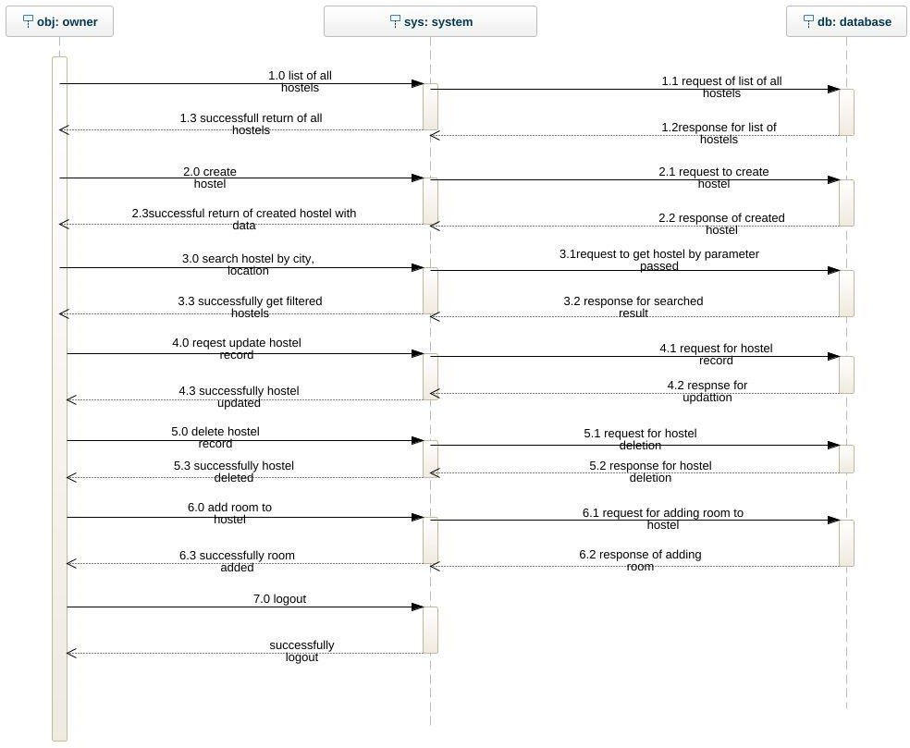

* + 1. **Sequence Diagram for students**

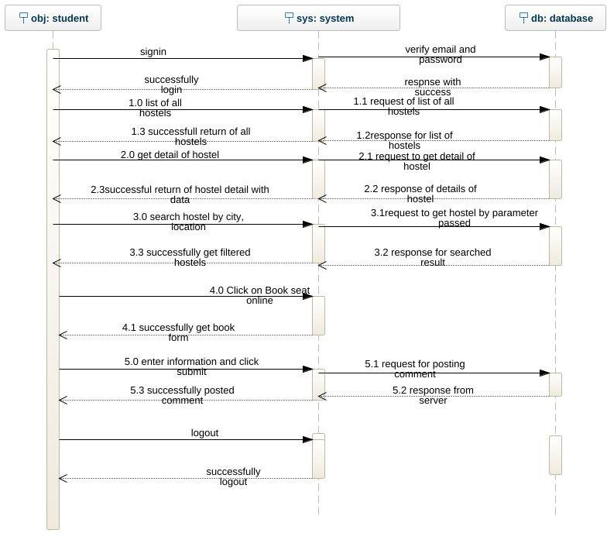

##### 3.23 Sequence Diagram for Job Provider

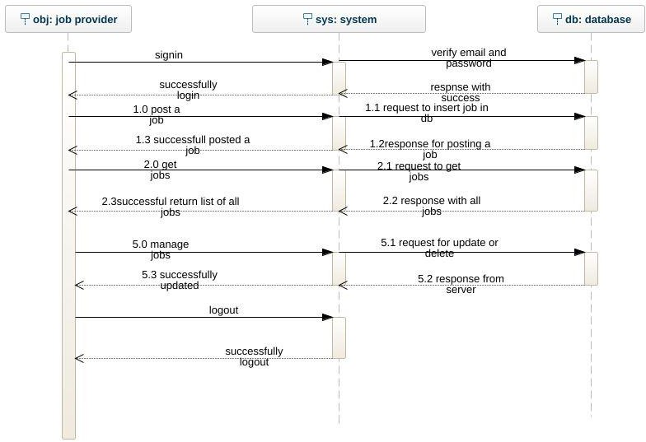

**3.2.4 Sequence Diagram for Job Seeker**

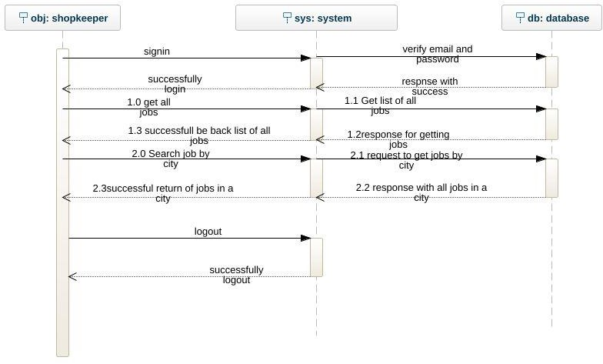

##### 3.2.4 Sequence Diagram for Shopkeeper

* + 1. **Sequence Diagram for Shopkeeper**

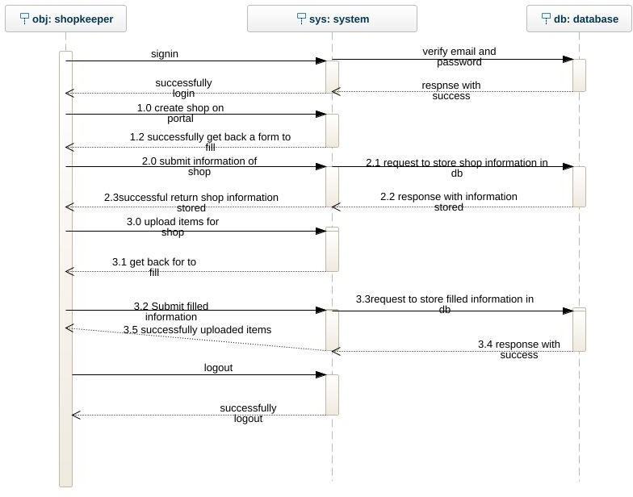

* + 1. **Sequence Diagram for client who wants to buy something from shop**

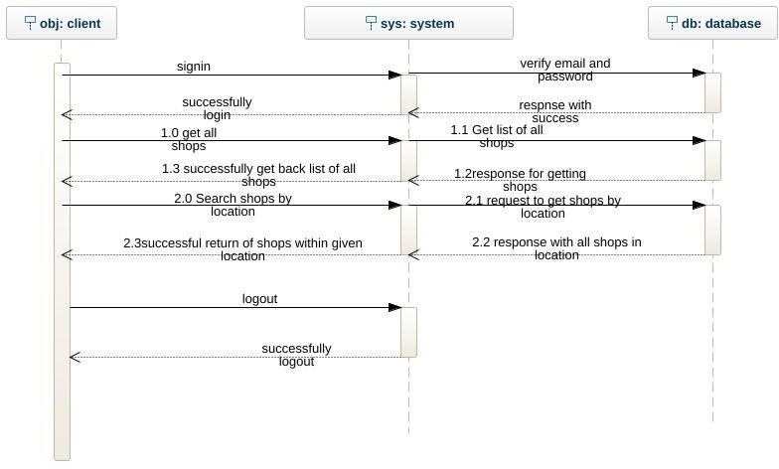

* + 1. **Register New User**

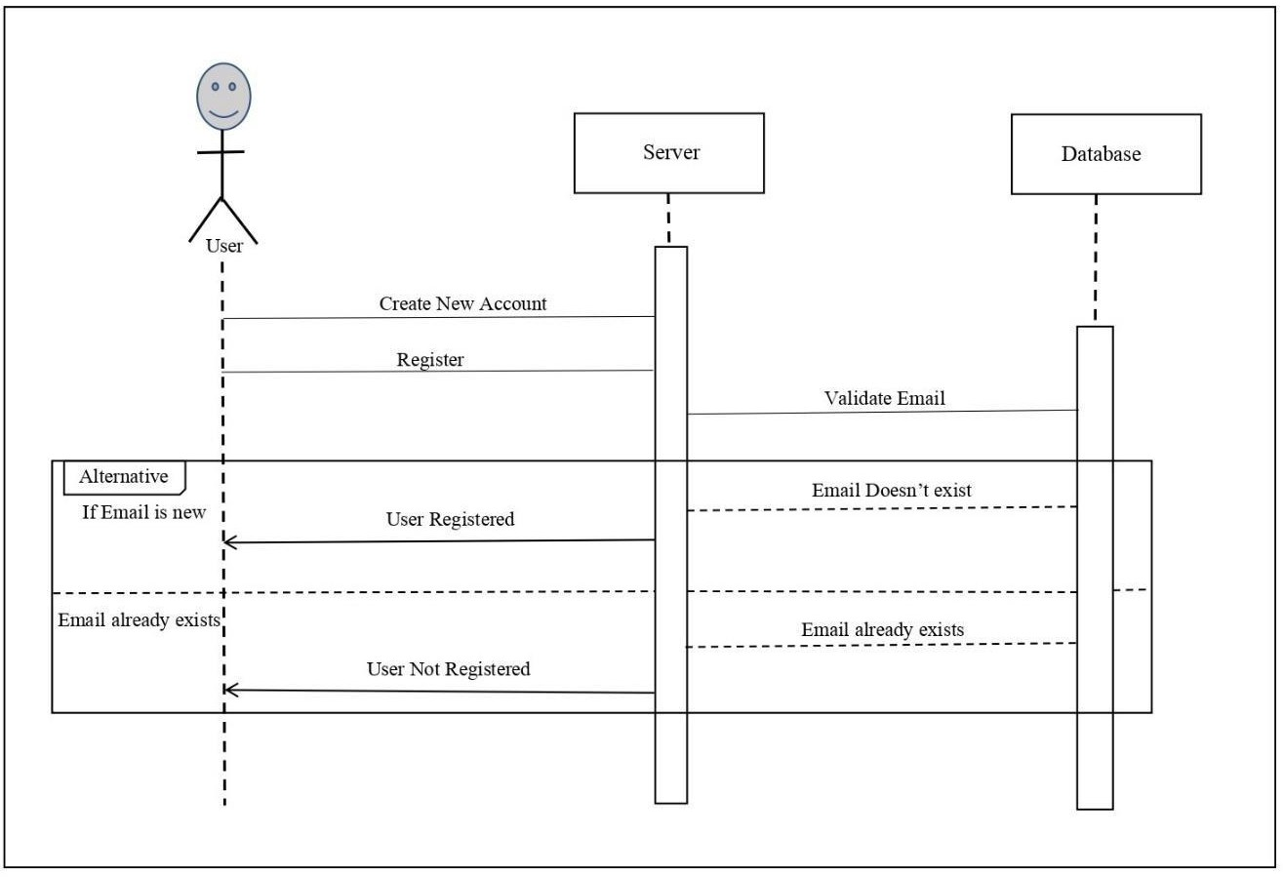

*System Design*

32

*System Design*

*System Design*

### CLASS DIAGRAM

A class diagram is primarily designed for developers to provide the conceptual model and architecture of the system being developed. Typically, a class diagram consists of more than one class or all the created classes for a system.

Considered to be the type of the structural diagrams as it represents the whole structure of the specific systems. Also has the similarity with the flow chart. Class diagram has three main parts represented by the rectangular box. Three parts represent the following things:

* + 1. First part: Name of the specific class.
    2. Second part: Qualities or Attributes of the specific class.
    3. Third part: List of functions a specific class can execute.

Figure 3. 2 Class Diagram

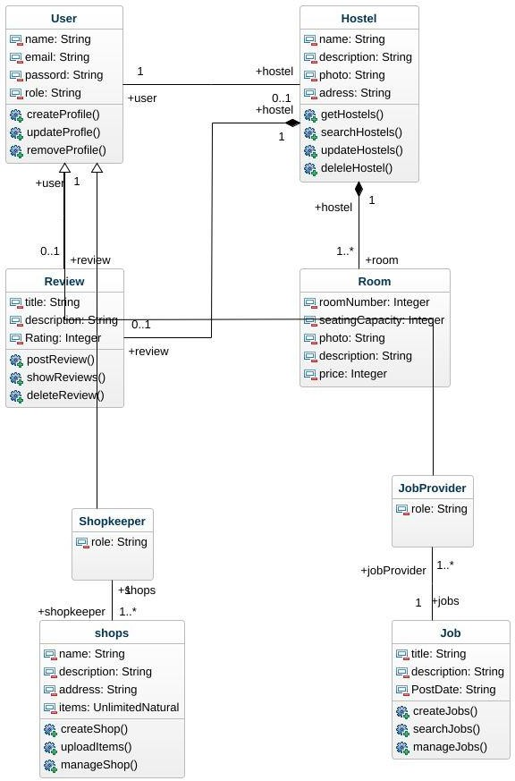

41

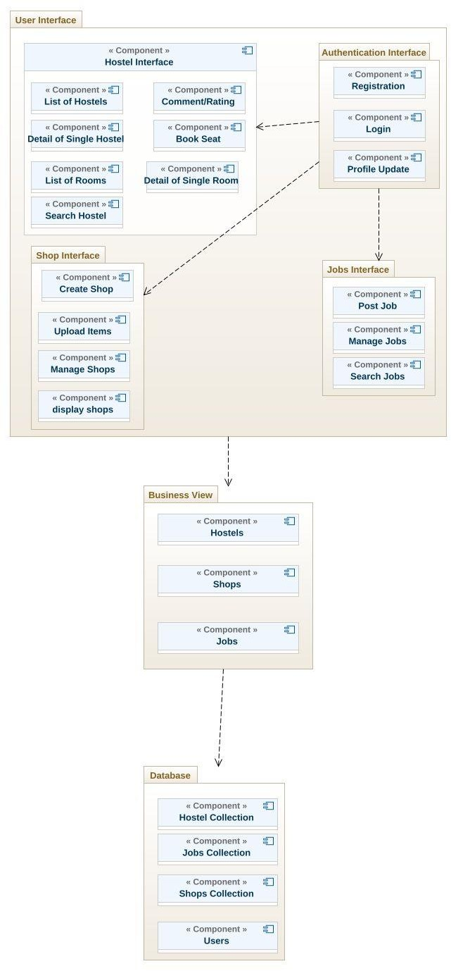

## 3.4 Deployment Diagram

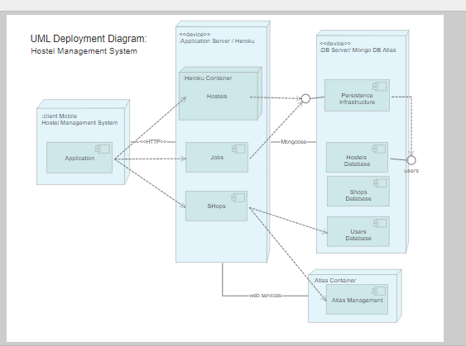

43

# CHAPTER 4 IMPLEMENTATION

* + 1. **Implementation**

Implementation is basically another word for coding/software programming. This chapter includes the component diagrams and deployment diagram. The implementation phase explains the design of the internal coding structure of the software.

### Functional Features of the Model:

The main features of the system are: User friendly

Friendly interface Responsiveness Reliability Security

### TOOLS AND TECHNIQUES

|  |  |  |  |
| --- | --- | --- | --- |
| **Platform:** API Based Mobile App | | | |
| **1.** | Web | | |
| **2.** | Android | | |
| **3.** | iOS | | |
| **Tools and Technologies:** | | | |
| **Front End:** | | **Back End:** | |
| **1.** | React Native | **1.** | NodeJS |
| **2.** | Android Studio | **2.** | MongoDB Cloud |
| **3.** |  | **3.** | Express framework |
| **4.** |  | **4.** | Google Map, Geocoder |
| **5.** |  | **5.** |  |

|  |  |  |  |
| --- | --- | --- | --- |
| **6.** |  |  |  |
| **7.** |  |  |  |
| **Supporting Tools and Technologies:** | | | |
| **1.** | Visual Studio Code | | |
| **2.** | Robo 3T | | |
| **3.** | GitHub | | |
| **4** | Postman | | |
| **5.** | Android Studio | | |
| **6.** | Heroku (used for live backend) | | |
| **7.** |  | | |

##### User Manual

**4.1 Signup/Login**

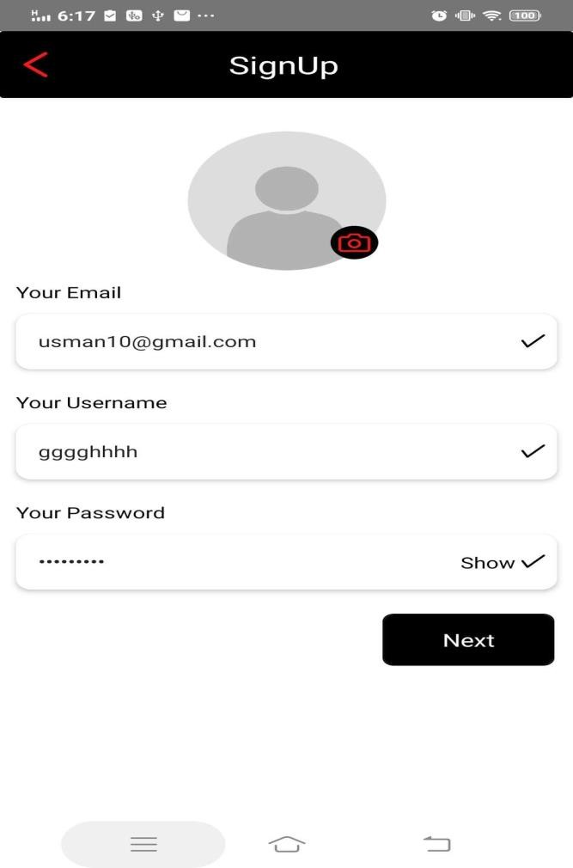

##### Signup: You can signup by using this screen

**if the user enters correct information, he will be loge din**

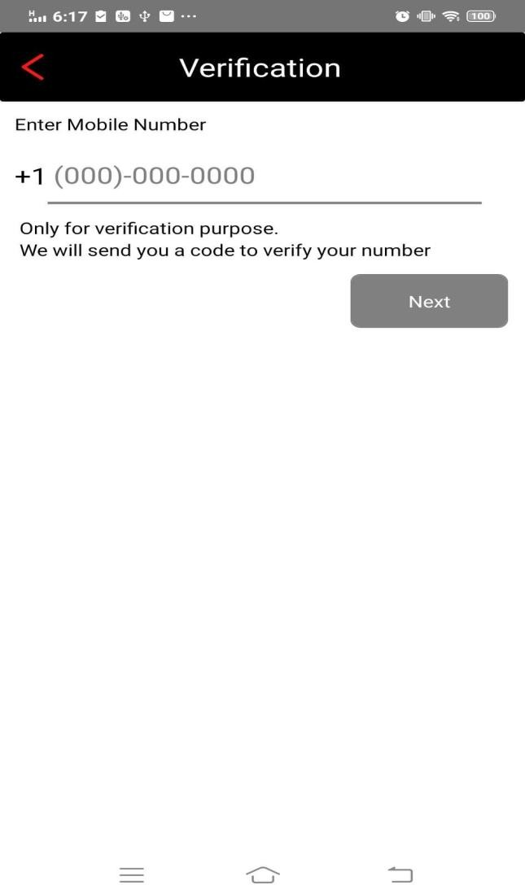

##### At the time signup, user have to get verification code, After this he/she can be able to do next

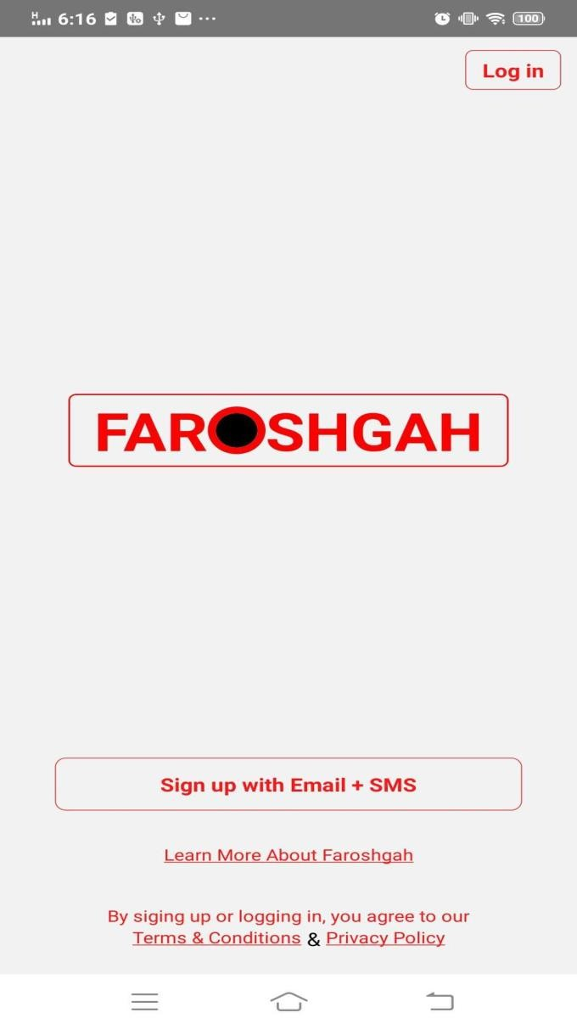

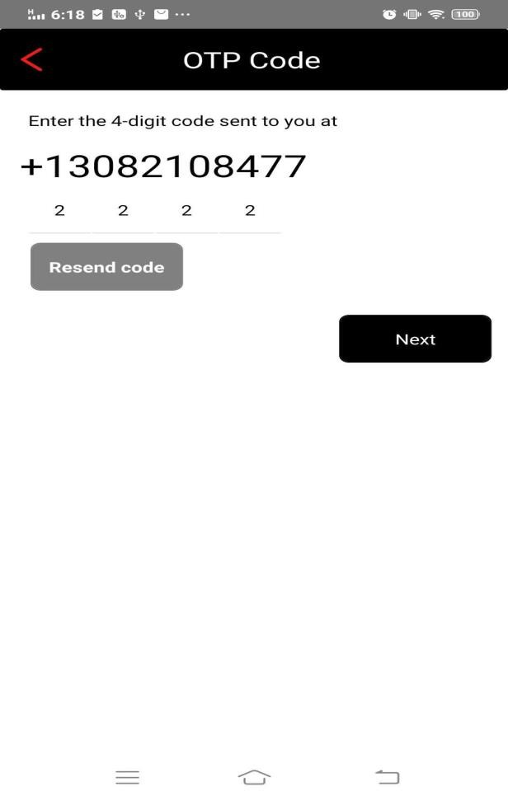 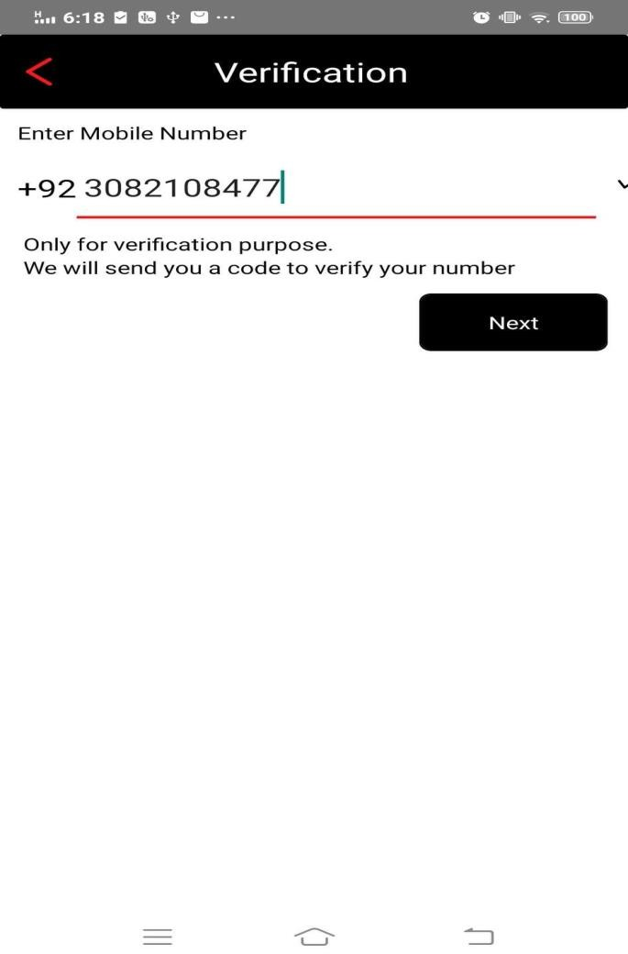

##### After getting verification code on mobile, fill it in the given screen to verify

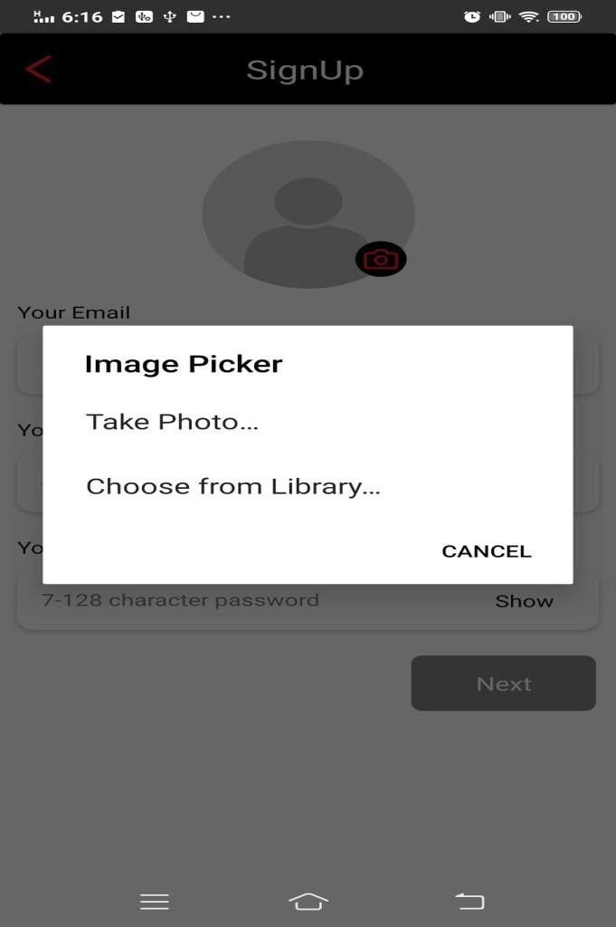

**Pick photo to set it on the profile**

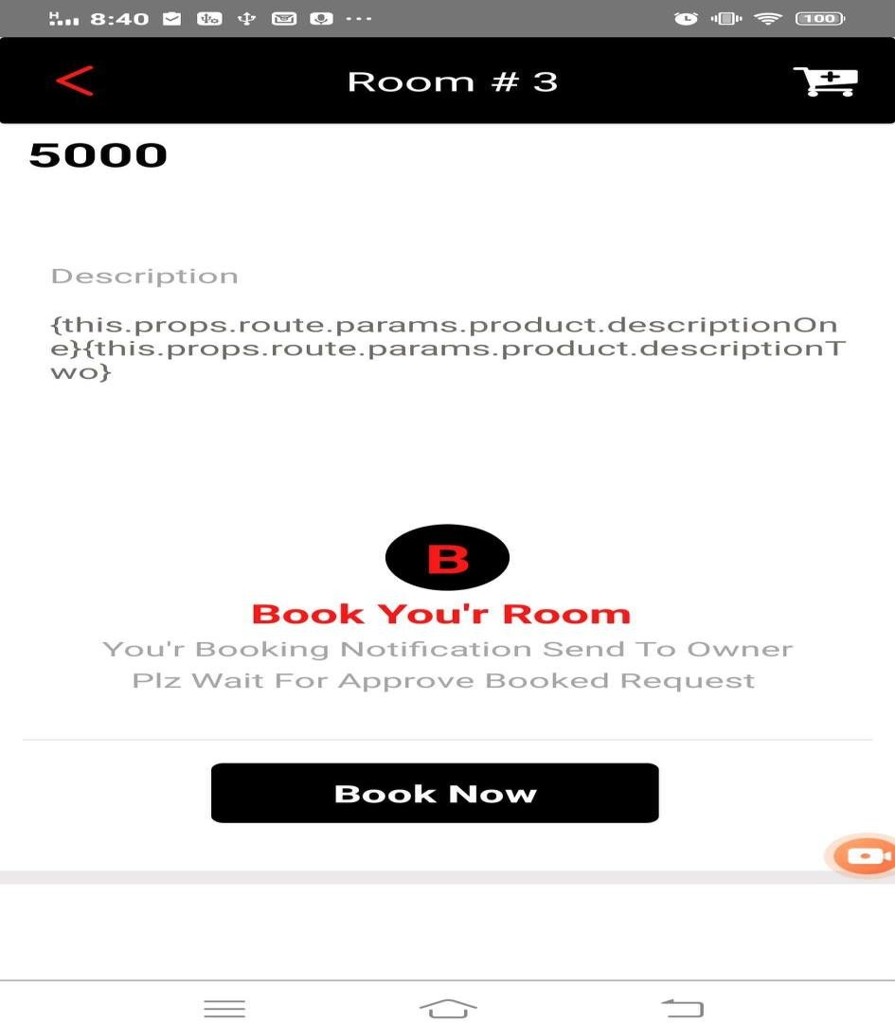

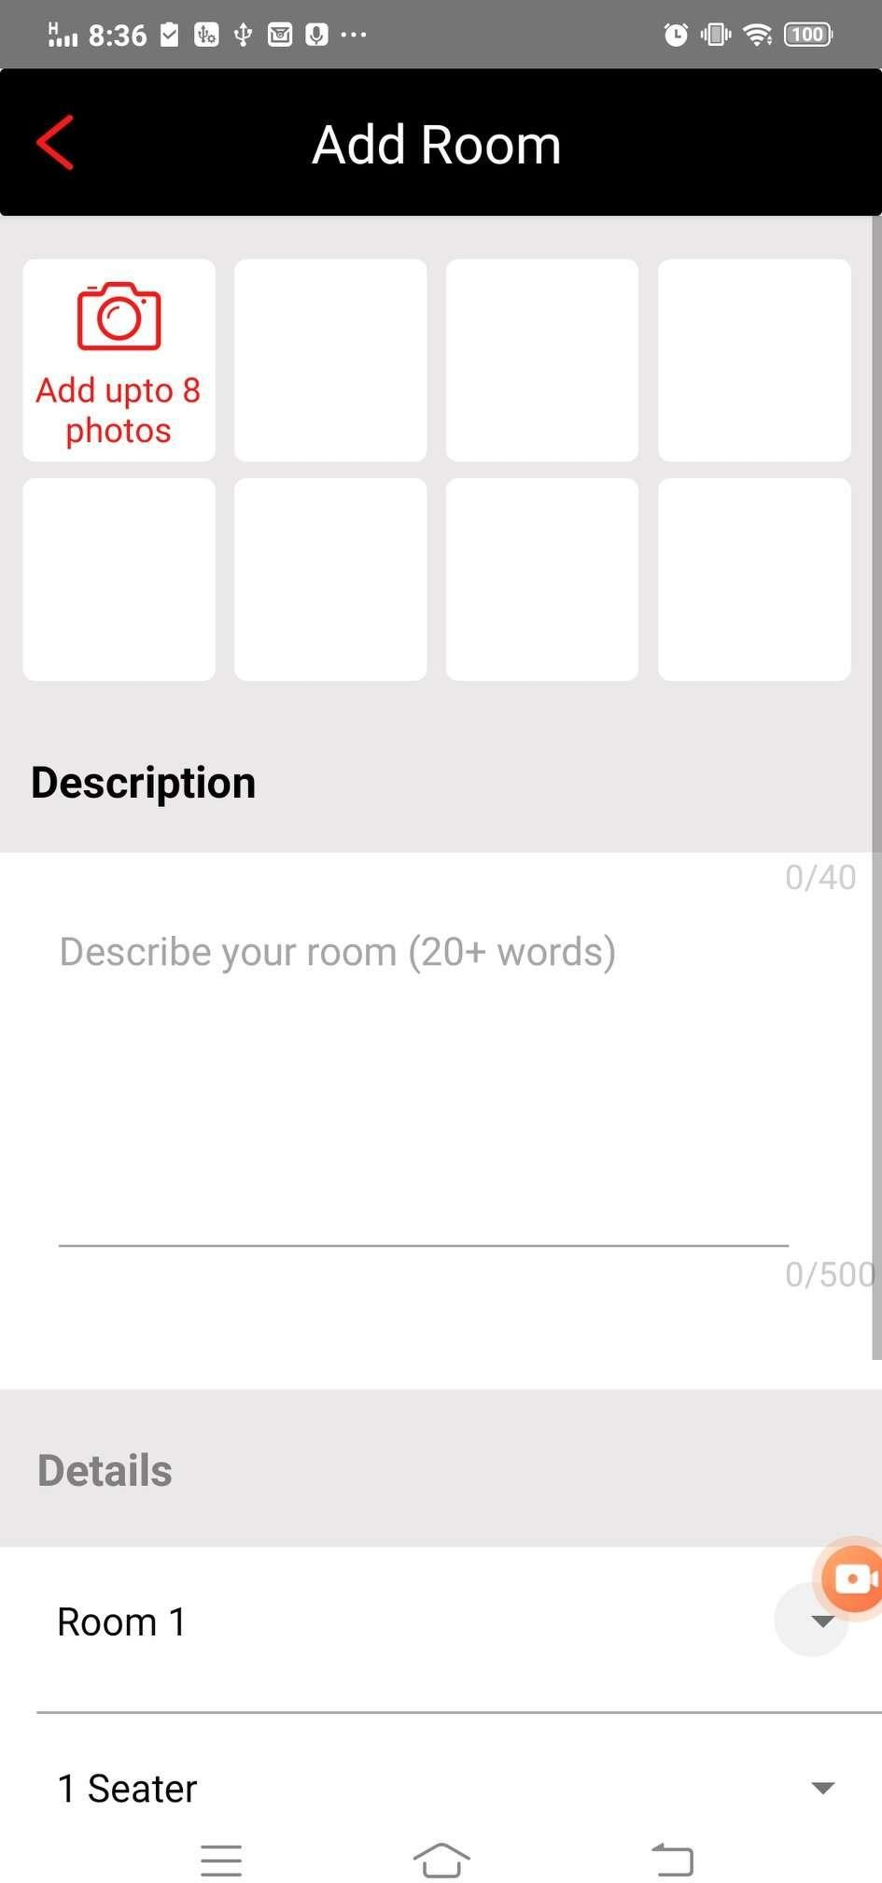

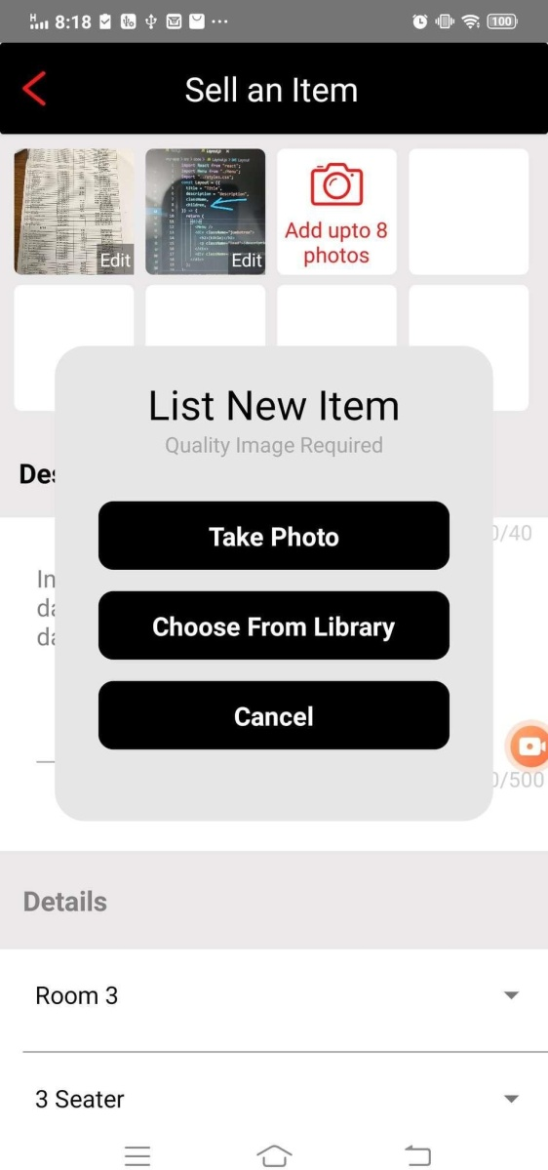

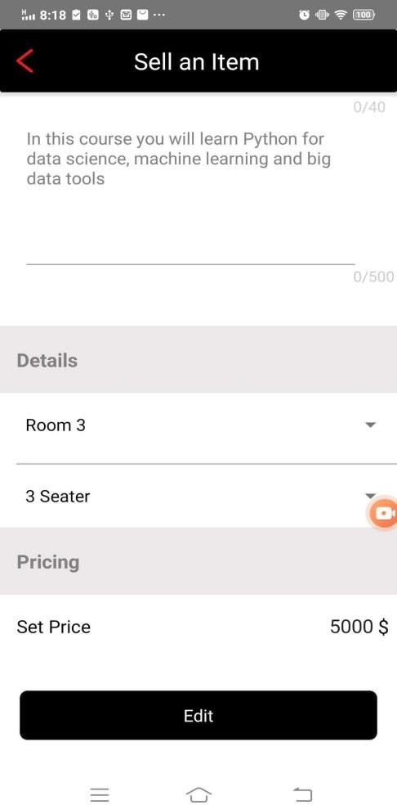

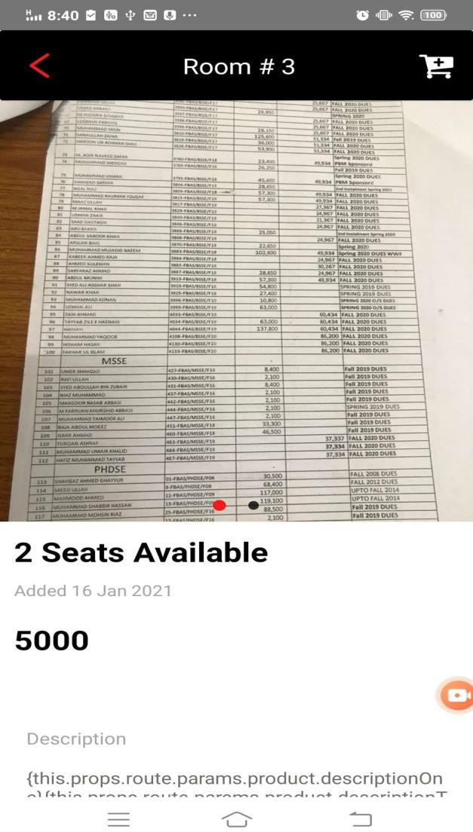

Live location

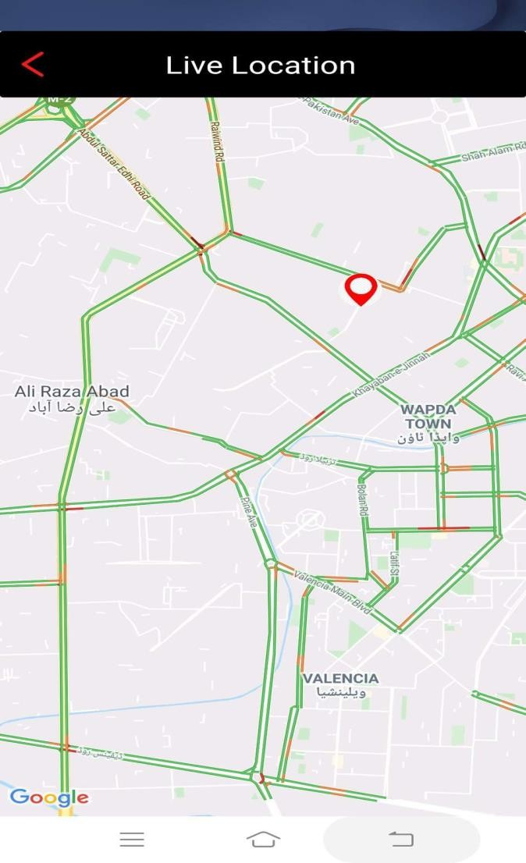

Rating

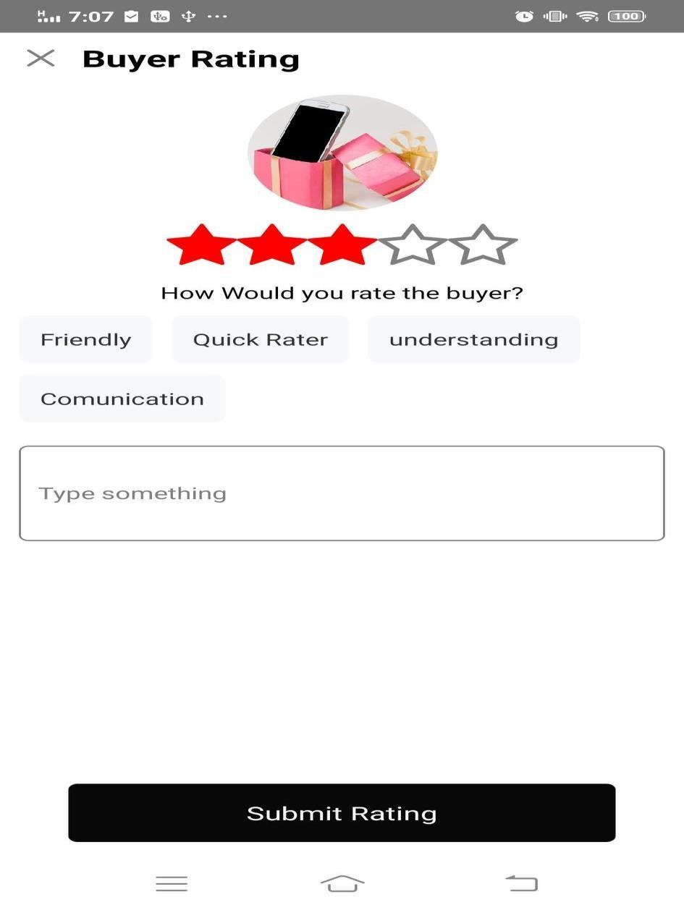

Publisher Account

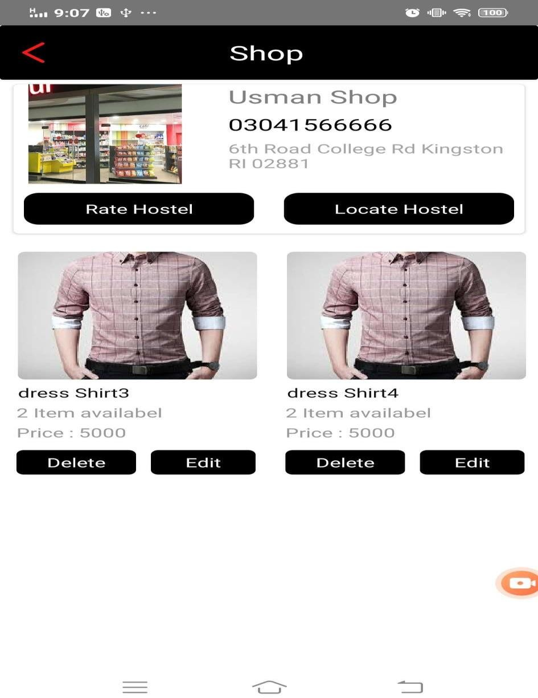Shop Section

Hostel Section

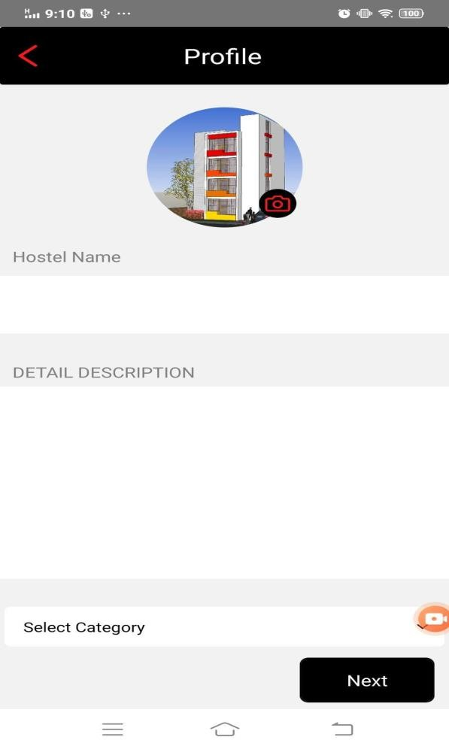

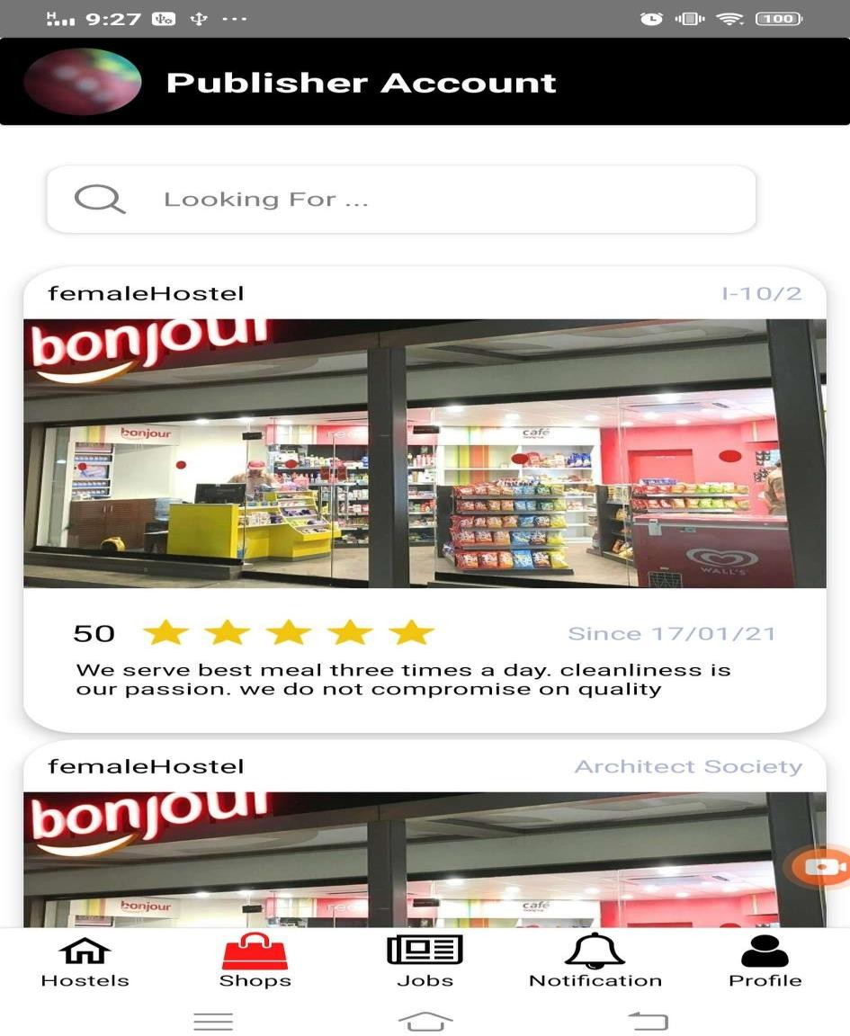Publisher Account

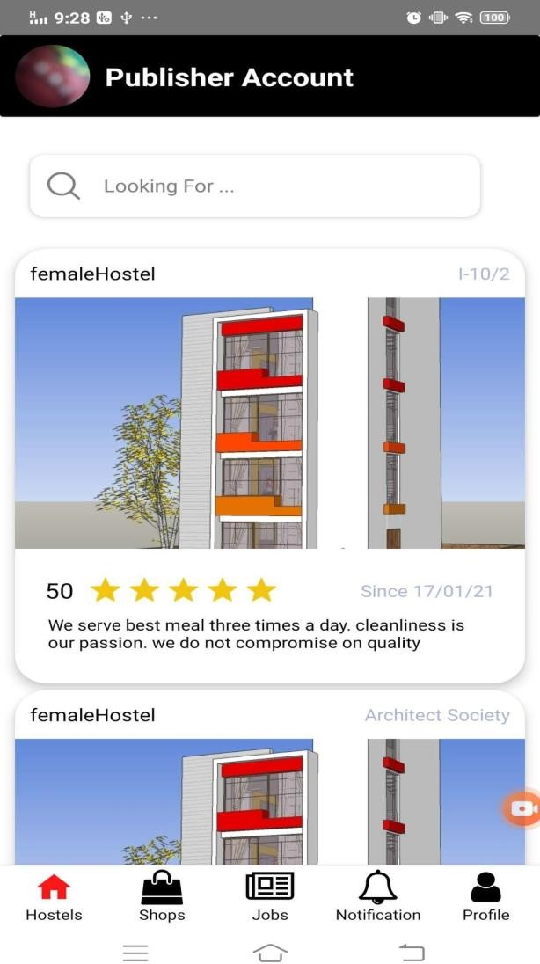

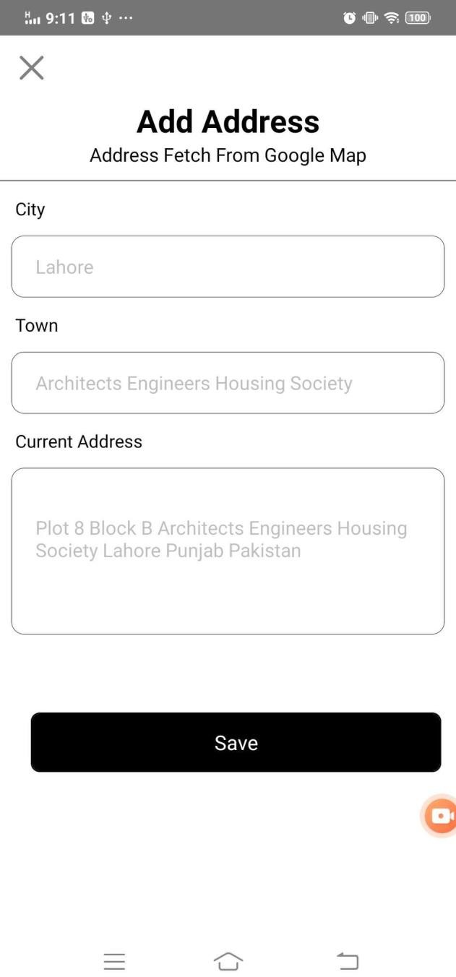

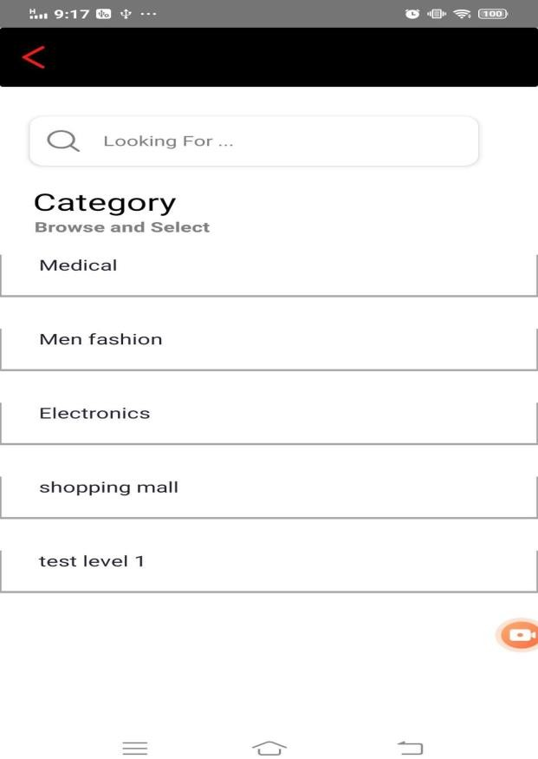

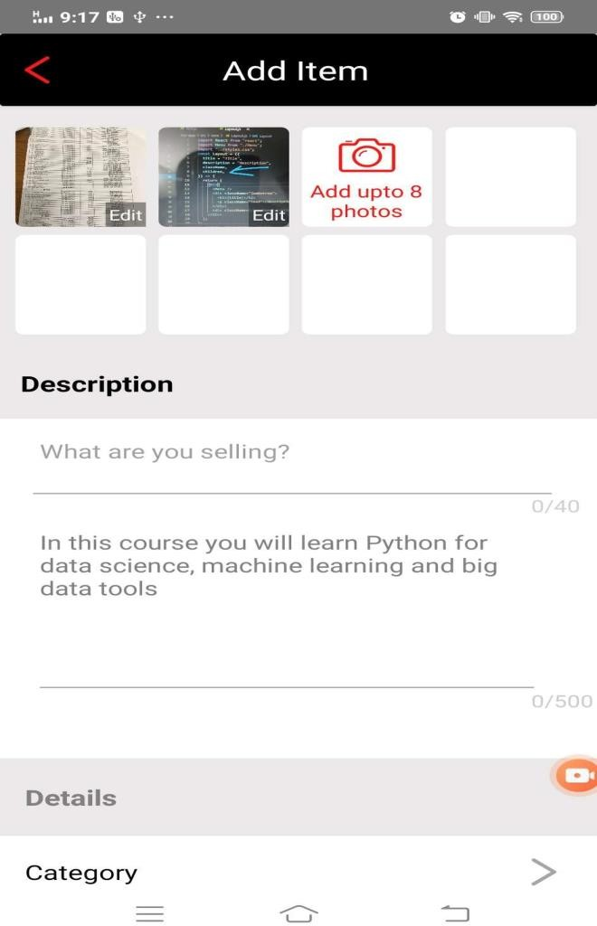

# CHAPTER 5

**System Testing**

## System Testing

Software testing is a post developmental step. It must be performed to minimize any potential errors or ambiguities. We have tested all the use cases and each of them is passed. The testing of the software gives a contentment to the developer as well as the user and it gives a quality assurance to all the stakeholders concerned.

### Black Box Testing

Black box testing, also known as behavioral testing, is a software testing method in which the internal structure/design/implementation of the item being tested is not these tests can be functional or non-functional though usually useful.

### White Box Testing

White box also known as Clear Box Testing, Open Box Testing, Glass Box Testing, Transparent Box Testing, Code-Based Testing and Structural Testing. This is a software testing method in which the internal structure/design/implementation of the item being tested is known to the tester.

### Test Cases

System-tester tests the system under specific circumstances and conditions also checks whether work or not under given circumstance.

##### Test Case Registration

Table 5.1 shows the test case registration:

|  |  |
| --- | --- |
| **Test Case ID** | TC-01 |
| **Functional Area/Module** | Registration |
| **Purpose** | To enable users to operate/use the system. |
| **Action to Perform** | User requests for registration. |

|  |  |
| --- | --- |
|  | Opt message sent for verification.  User verifies the OTP and Redirected to login after successful registration.  (User can register himself as Hostel owner or as user) |
| **Prerequisites** | Hostel owner and student are on the Website. |
| **Test Case Engineer** | Kaleem Ullah |
| **Environment** | Android |
| **Expected Result(s)** | Account Created successfully. |
| **Comments:** Test passed successfully | |

Table 5.1 Test Case Registration

##### Test Case Login

Table 5.2 shows the test case login

|  |  |
| --- | --- |
| **Test Case ID** | TC-02 |
| **Functional Area/Module** | Login |
| **Purpose** | To Enable user to run the system |
| **Action to Perform** | User Provides username and password.  Redirect to Home page after successful attempt. |
| **Prerequisites** | User Account Created successfully. |
| **Test Case Engineer** | Kaleem Ullah |
| **Environment** | Android |
| **Expected Result(s)** | Redirect to home |
| **Comments:** Test passed successfully | |

Table 5.2 Test Case Login

##### Test Case Add Hostel:

Table 5.3 shows the test case add hostel:

|  |  |
| --- | --- |
| **Test Case ID** | TC-03 |

|  |  |
| --- | --- |
| **Functional Area/Module** | Add hostel |
| **Purpose** | To show hostel online to hostel seekers. |
| **Action to Perform** | Create a hostel  And publish it online |
| **Prerequisites** | Login |
| **Test Case Engineer** | Kaleem Ullah |
| **Environment** | Android |
| **Expected Result(s)** | Hostel created |
| **Comments:** Test passed successfully | |

Table 5.3 Test Case Add Hostel

##### Test Case Search Hostel:

Table 5.4 shows the test case search hostel:

|  |  |
| --- | --- |
| **Test Case ID** | TC-04 |
| **Functional Area/Module** | Search Hostel |
| **Purpose** | To Enable students/job seekers to search hostels. |
| **Action to Perform** | User clicks the search bar.  Searches the hostels by city or location/street/zipcode. |
| **Prerequisites** | Login, user can search hostel after login |
| **Test Case Engineer** | Kaleem Ullah |
| **Environment** | Android |
| **Expected Result(s)** | Searching for hostels is done |
| **Comments:** Test passed successfully | |

Table 5.4 Test Case Search Hostel

##### Test Case Update Hostel Record:

Table 5.5 shows the test case Update Hostel Record:

|  |  |
| --- | --- |
| **Test Case ID** | TC-05 |
| **Functional Area/Module** | Update Hostel Record |
| **Purpose** | To update the record of hostel |
| **Action to Perform** | Updating record of hostel |
| **Prerequisites** | Login, only admin or authenticated hostel owner can do that |

67

|  |  |
| --- | --- |
| **Test Case Engineer** | Kaleem Ullah |
| **Environment** | Android |
| **Expected Result(s)** | Updating record of hostel is completed |
| **Comments:** Test passed successfully | |

Table 5.5 Test Case Update Hostel Record

##### Test Case Delete Hostel Record:

Table 5.6 shows the test case delete hostel record:

|  |  |
| --- | --- |
| **Test Case ID** | TC-06 |
| **Functional Area/Module** | Delete hostel record |
| **Purpose** | To delete the record of hostel |
| **Action to Perform** | Deleting hostel record from db |
| **Prerequisites** | Login, register as a hostel owner |
| **Test Case Engineer** | Kaleem Ullah |
| **Environment** | Android |
| **Expected Result(s)** | Deletion of hostel is done |
| **Comments:** Test passed successfully | |

Table 5.6 Test Case Delete Hostel Record

##### Test Case Search hostel within a specific location:

Table 5.7 shows the test case Search hostel within location:

|  |  |
| --- | --- |
| **Test Case ID** | TC-07 |
| **Functional Area/Module** | Search hostel within location |
| **Purpose** | To get hostels located in chosen location |
| **Action to Perform** | Searching hostel |
| **Prerequisites** | Navigate to the search page |
| **Test Case Engineer** | Kaleem Ullah |
| **Environment** | Android |
| **Expected Result(s)** | Searching of hostels is done |
| **Comments:** Test passed successfully | |

Table 5.7 Test Case Search Hostel within a Specific Location

##### Test Case Book Hostel’s Seat:

Table 4.8 shows the test case Book hostel room/seat:

|  |  |
| --- | --- |
| **Test Case ID** | TC-08 |
| **Functional Area/Module** | Book hostel room/seat |
| **Purpose** | To book hostel online |
| **Action to Perform** | Booking hostel is done |
| **Prerequisites** | Login, add profile |
| **Test Case Engineer** | Kaleem Ullah |
| **Environment** | Android |
| **Expected Result(s)** | Booking of hostel is done |
| **Comments:** Test passed successfully | |

Table 4.8 Test Case Book Hostel Room/Seat

##### Test Case Review or Rating:

Table 5.9 shows the test case Review or Rating:

|  |  |
| --- | --- |
| **Test Case ID** | TC-09 |
| **Functional Area/Module** | Review or Rating |
| **Purpose** | To give the rating to the hostel |
| **Action to Perform** | Giving rating to hostel |
| **Prerequisites** | Login, add profile |
| **Test Case Engineer** | Kaleem Ullah |
| **Environment** | Android |
| **Expected Result(s)** | Rating is given to the hostel |
| **Comments:** Test passed successfully | |

Table 5.9 Test Case Review or Rating

##### TEST CASES FOR SHOP MANAGEMENT SYSTEM

* + 1. **Test Case Create New Shop:**

Table 5.10 shows the test case Create New Shop:

|  |  |
| --- | --- |
| **Test Case ID** | TC-10 |
| **Functional Area/Module** | Create New Shop |
| **Purpose** | To create shop on portal |
| **Action to Perform** | Creation of shop on portal |
| **Prerequisites** | Login, add profile |

69

|  |  |
| --- | --- |
| **Test Case Engineer** | Kaleem Ullah |
| **Environment** | Android |
| **Expected Result(s)** | Creation of shop is done |
| **Comments:** Test passed successfully | |

Table 5.10 Test Case Create New Shop

* + 1. **Test Case Upload Items for Shop:**

Table 5.11 shows the test case Upload Items for Shop:

|  |  |
| --- | --- |
| **Test Case ID** | TC-11 |
| **Functional Area/Module** | Upload Items for Shop |
| **Purpose** | To upload items for shop |
| **Action to Perform** | Uploading items for shop |
| **Prerequisites** | Login, only shopkeeper can do that |
| **Test Case Engineer** | Kaleem Ullah |
| **Environment** | Android |
| **Expected Result(s)** | Uploading items done |
| **Comments:** Test passed successfully | |

Table 5.11 Test Case Upload Items for Shop

##### Test Case Update Items for Shop:

Table 5.12 shows the test case Update Items for Shop:

|  |  |
| --- | --- |
| **Test Case ID** | TC-12 |
| **Functional Area/Module** | Update Items for Shop |
| **Purpose** | To update items for shop |
| **Action to Perform** | Updating items for shop |
| **Prerequisites** | Login, add profile |
| **Test Case Engineer** | Kaleem Ullah |
| **Environment** | Android |
| **Expected Result(s)** | Updating item is done |
| **Comments:** Test passed successfully | |

Table 5.12 Test Case Update items for shop

##### Test Case Delete Shop Items & Detail:

Table 5.13 shows the test case Delete Shop Items and detail:

|  |  |
| --- | --- |
| **Test Case ID** | TC-13 |

|  |  |
| --- | --- |
| **Functional Area/Module** | Delete Shops and its detail |
| **Purpose** | To delete the shops from database |
| **Action to Perform** | Deleting shop and its detail |
| **Prerequisites** | Login, add profile |
| **Test Case Engineer** | Kaleem Ullah |
| **Environment** | Android |
| **Expected Result(s)** | Deleting shop is done |
| **Comments:** Test passed successfully | |

Table 5.13 Test Case Delete Shops and its detail

##### Test Case Search Shop:

Table 5.14 shows the test case Search Shop:

|  |  |
| --- | --- |
| **Test Case ID** | TC-14 |
| **Functional Area/Module** | Search Shop |
| **Purpose** | To search the desired shops |
| **Action to Perform** | Searching shops online |
| **Prerequisites** | Come to the search page |
| **Test Case Engineer** | Kaleem Ullah |
| **Environment** | Android |
| **Expected Result(s)** | Searching is done |
| **Comments:** Test passed successfully | |

Table 5.14 Test Case Search Shop

##### Test Case Order Item:

Table 5.15 shows the test case Order Item:

|  |  |
| --- | --- |
| **Test Case ID** | TC-15 |
| **Functional Area/Module** | Order Item |
| **Purpose** | To buy an item from the shop |
| **Action to Perform** | Order items from the shop |
| **Prerequisites** | Login, add profile |
| **Test Case Engineer** | Kaleem Ullah |
| **Environment** | Android |
| **Expected Result(s)** | Order is done |

71

**Comments:**

Test

passed successfully

Table 5.15 Test Case Order Item

##### USE CASES FOR JOBS

* + 1. **Test Case Create Job:**

Table 5.16 shows the test case Create Job:

|  |  |
| --- | --- |
| **Test Case ID** | TC-16 |
| **Functional Area/Module** | Create Job |
| **Purpose** | To show jobs online for job seekers. |
| **Action to Perform** | Uploading jobs for job seekers |
| **Prerequisites** | Login, add profile |
| **Test Case Engineer** | Kaleem Ullah |
| **Environment** | Android |
| **Expected Result(s)** | Uploading jobs is done |
| **Comments:** Test passed successfully | |

Table 5.16 Test Case Create Job

##### TEST CASES FOR ADD JOBS

* + 1. **Test Case Update Jobs detail:**

Table 5.17 shows the test case Update Jobs detail:

|  |  |
| --- | --- |
| **Test Case ID** | TC-17 |
| **Functional Area/Module** | Update Jobs detail |
| **Purpose** | Job updating by client those already added |
| **Action to Perform** | Client updates the jobs for job seekers |
| **Prerequisites** | Registered and logged-in client. |
| **Test Case Engineer** | Kaleem Ullah |
| **Environment** | Android |
| **Expected Result(s)** | Jobs are managed successfully. |
| **Comments:** Test passed successfully | |

Table 5.17 Test Case Update Jobs detail

##### Test Case Delete the Job:

Table 5.18 shows the test case Delete the Job:

|  |  |
| --- | --- |
| **Test Case ID** | TC-18 |
| **Functional Area/Module** | Delete the Job |
| **Purpose** | delete jobs by provider those already added |
| **Action to Perform** | Providers defines the jobs for job seekers and delete the job. |
| **Prerequisites** | Registered and logged-in client. |
| **Test Case Engineer** | Kaleen Ullah |
| **Environment** | Android |
| **Expected Result(s)** | Jobs are deleted successfully. |
| **Comments:** Test passed successfully | |

Table 5.18 Test Case Delete the Job By Provider

##### Test Case Delete the Job:

Table 5.19 shows the test case Delete the Job:

|  |  |
| --- | --- |
| **Test Case ID** | TC-19 |
| **Functional Area/Module** | Delete the Job |
| **Purpose** | delete jobs by provider those already added |
| **Action to Perform** | Providers defines the jobs for job seekers and delete the job. |
| **Prerequisites** | Registered and logged-in client. |
| **Test Case Engineer** | Kaleem Ullah |
| **Environment** | Android |
| **Expected Result(s)** | Jobs are deleted successfully. |
| **Comments:** Test passed successfully | |

Table 5.19 Test Case Delete the Job

73

*Feroshgah 62*

# CHAPTER 6 CONCLUSION

*References Appendix*

## CONCLUSION

By use of Feroshgah application the user can search and finds hostels, shops, jobs, as per location. This application with elegant design provides ease to students and owners and can make their life by saving lots of time. It provides facility to get hostels, shops and jobs online without wasting your time by visiting hostels or shops on site. You can search to find shops, hostels and jobs. It gives facility to provide the best result based on searched you made. You can manage shops, hostels without any difficulty.

It is fully secured and working application. It is secured from all types of security threads and provide authentication and authorization to the users. Now one can make you fool by

using this platform. It provides big opportunity to those who seeks hostel to get comfortable living in hostels.

### FUTURE EXTENSION

Moving further Feroshgah is planning to improve its current features as well as add new features that will meet all the expectations of its clients. Here are some planned improvements that will be part of Feroshgah in near future.

* + - **Add Hotels:** Feroshgah is planning to add Hotels service module where user will be able to add hotels and other users can find it for rent.

*Chapter 06 conclusion*

## REFERENCES

[www.stackoverflow.com](http://www.stackoverflow.com/) [www.wikipedia.com](http://www.wikipedia.com/) [www.tutorialpoints.com](http://www.tutorialpoints.com/) [www.youtube.com](http://www.youtube.com/) [www.w3school.com](http://www.w3school.com/)